1. Install latest cockpit (>= 1.8.35)
2. Install latest firmware (>= 2.6.4)
3. Install sensor explorer from vectornav ([www.vectornav.com/Downloads/SensorExplorer/1.5.1/SensorExplorer-1.5.1.exe](http://www.vectornav.com/Downloads/SensorExplorer/1.5.1/SensorExplorer-1.5.1.exe))
4. Run cockpit
5. Open engine room
6. Unlock the controls, press the Calibrate/Configure compass button (looks like a magnet)
7. The Compass Setting dialog should appear

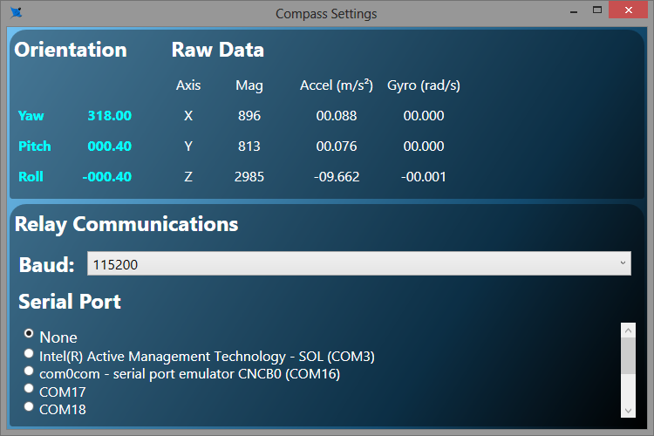

1. In the radio selection in the lower pane, delect one end of a virtual port pair. (Recommend COM17). Leave the baudrate at 115200

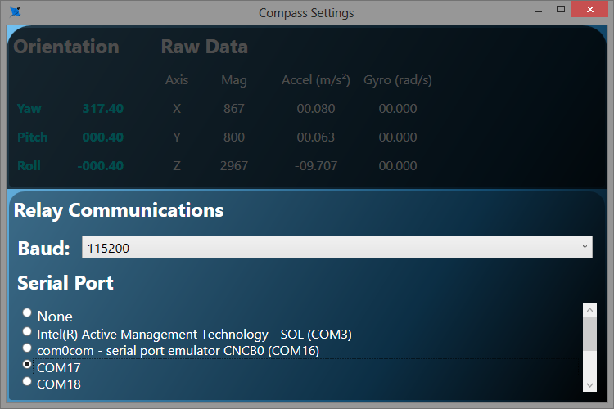

1. Minimize (don’t dismiss) the compass settings dialog, engine room, and the video window. (or move them to another screen)
2. Run sensor explorer
3. Select the other end of the virtual port (COM18), insure “Query Sensor…” is checked, and the baud rate is 115200.
4. Press “Connect>>”

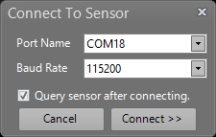

1. Make sure the vn100 settings in the property tab are correct (see attached)
2. Right click on Sensor A in the Project Pane, select “Commands\Write Settings to Sensor Memory” if any changes were made in #13
3. Right click on Sensor A in the Project Pane, select “Tasks\Perform Hard/Soft Iron Calibration”, the calibration wizard dialog should appear

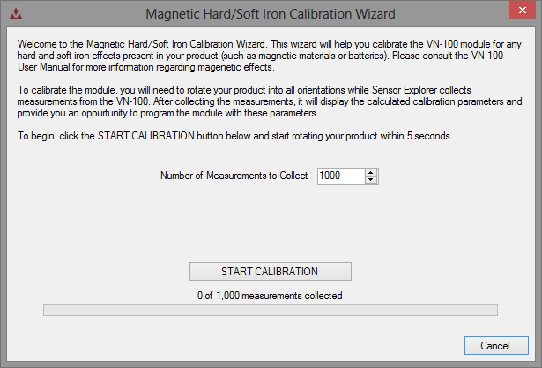

1. Press “START CALIBRATION”
2. Slowly rotate the vehicle around all axis, as if painting the inside of a sphere.

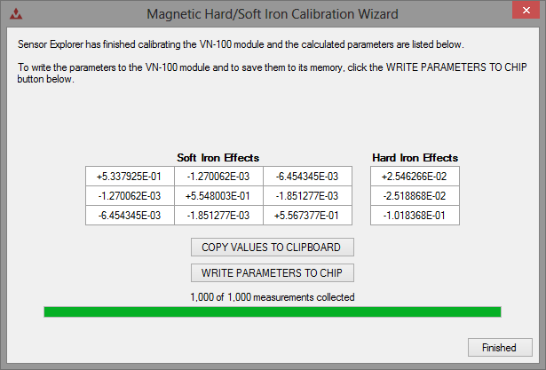

1. When done, press “WRITE PARAMETERS TO CHIP” to save the calibration
2. Close sensor explorer
3. Close the Compass Settings Dialog in Cockpit
4. Close EngineRoom.
5. Cross check the calibration as best as you can.
6. Good to GO!